**Lab5. Creating Functions and Packages**

1. Create at least 3 functions for your database. You may use the anonymous blocks you created in Lab 2 as a basis.
2. At least 2 functions must be with parameters.
3. Combine your procedures (Lab 4) and functions (Lab 5) into at least 2 packages. Procedures and functions of one package must be logically related.
4. During the defense you must demonstrate the execution of procedures and functions.

CREATE OR REPLACE FUNCTION GET_USER_BY_CARD_NUMBER(

p_card_number IN VARCHAR2

) RETURN Users%ROWTYPE AS

v_user_details Users%ROWTYPE;

BEGIN

SELECT u.*

INTO v_user_details

FROM Cards c

JOIN Users u ON c.user_id = u.user_id

WHERE c.card_number = p_card_number;

RETURN v_user_details;

EXCEPTION

WHEN NO_DATA_FOUND THEN

RETURN NULL;

END GET_USER_BY_CARD_NUMBER;

/

DECLARE

v_user_info Users%ROWTYPE;

BEGIN

v_user_info := GET_USER_BY_CARD_NUMBER('1234566660123456');

DBMS_OUTPUT.PUT_LINE('User ID: ' || v_user_info.user_id);

DBMS_OUTPUT.PUT_LINE('Username: ' || v_user_info.uname);

DBMS_OUTPUT.PUT_LINE('Last Name: ' || v_user_info.ulastname);

DBMS_OUTPUT.PUT_LINE('Phone Number: ' || NVL(v_user_info.uphone_number, 'N/A'));

DBMS_OUTPUT.PUT_LINE('Password: ' || v_user_info.user_password);

DBMS_OUTPUT.PUT_LINE('PIN: ' || v_user_info.user_pin);

END;

/

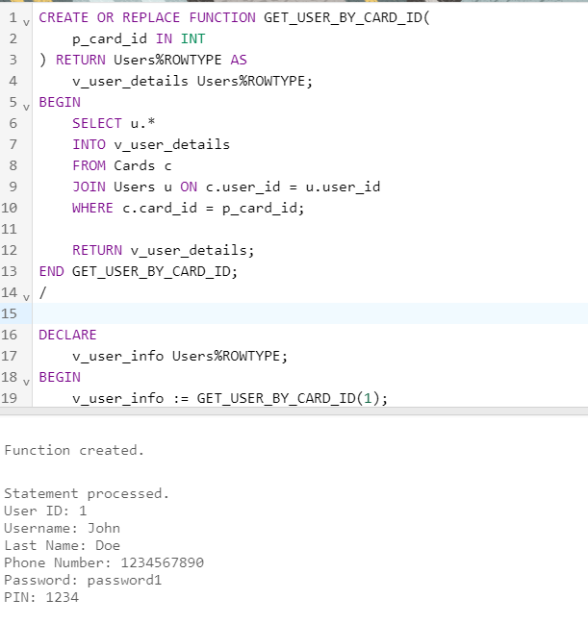

CREATE OR REPLACE FUNCTION GET_USER_BY_CARD_ID(

p_card_id IN INT

) RETURN Users%ROWTYPE AS

v_user_details Users%ROWTYPE;

BEGIN

SELECT u.*

INTO v_user_details

FROM Cards c

JOIN Users u ON c.user_id = u.user_id

WHERE c.card_id = p_card_id;

RETURN v_user_details;

END GET_USER_BY_CARD_ID;

/

DECLARE

v_user_info Users%ROWTYPE;

BEGIN

v_user_info := GET_USER_BY_CARD_ID(1);

DBMS_OUTPUT.PUT_LINE('User ID: ' || v_user_info.user_id);

DBMS_OUTPUT.PUT_LINE('Username: ' || v_user_info.uname);

DBMS_OUTPUT.PUT_LINE('Last Name: ' || v_user_info.ulastname);

DBMS_OUTPUT.PUT_LINE('Phone Number: ' || NVL(v_user_info.uphone_number, 'N/A'));

DBMS_OUTPUT.PUT_LINE('Password: ' || v_user_info.user_password);

DBMS_OUTPUT.PUT_LINE('PIN: ' || v_user_info.user_pin);

END;

/

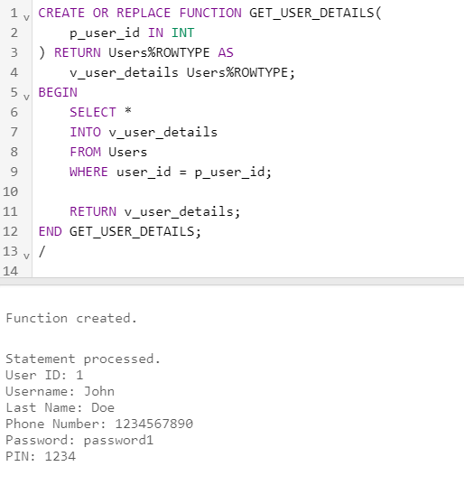

CREATE OR REPLACE FUNCTION GET_USER_DETAILS(

p_user_id IN INT

) RETURN Users%ROWTYPE AS

v_user_details Users%ROWTYPE;

BEGIN

SELECT *

INTO v_user_details

FROM Users

WHERE user_id = p_user_id;

RETURN v_user_details;

END GET_USER_DETAILS;

/

DECLARE

v_user_details Users%ROWTYPE;

BEGIN

v_user_details := GET_USER_DETAILS(1);

DBMS_OUTPUT.PUT_LINE('User ID: ' || v_user_details.user_id);

DBMS_OUTPUT.PUT_LINE('Username: ' || v_user_details.uname);

DBMS_OUTPUT.PUT_LINE('Last Name: ' || v_user_details.ulastname);

DBMS_OUTPUT.PUT_LINE('Phone Number: ' || NVL(v_user_details.uphone_number, 'N/A'));

DBMS_OUTPUT.PUT_LINE('Password: ' || v_user_details.user_password);

DBMS_OUTPUT.PUT_LINE('PIN: ' || v_user_details.user_pin);

END;

/

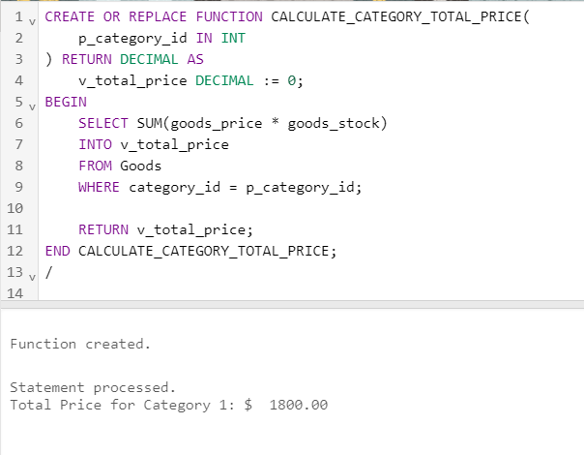

CREATE OR REPLACE FUNCTION CALCULATE_CATEGORY_TOTAL_PRICE(

p_category_id IN INT

) RETURN DECIMAL AS

v_total_price DECIMAL := 0;

BEGIN

SELECT SUM(goods_price * goods_stock)

INTO v_total_price

FROM Goods

WHERE category_id = p_category_id;

RETURN v_total_price;

END CALCULATE_CATEGORY_TOTAL_PRICE;

/

DECLARE

v_total_price DECIMAL;

BEGIN

v_total_price := CALCULATE_CATEGORY_TOTAL_PRICE(1);

DBMS_OUTPUT.PUT_LINE('Total Price for Category 1: $' || TO_CHAR(v_total_price, '99999.99'));

END;

/

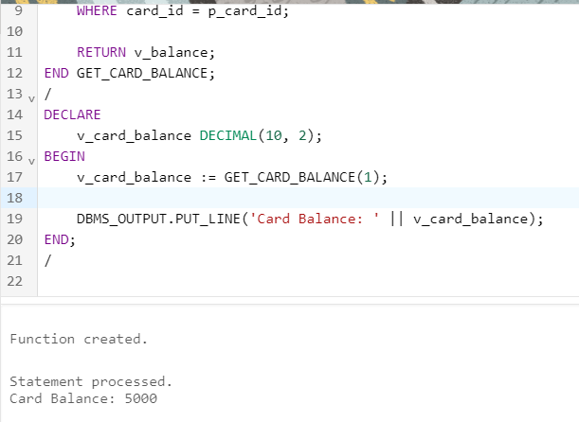

CREATE OR REPLACE FUNCTION GET_CARD_BALANCE(

p_card_id IN INT

) RETURN DECIMAL AS

v_balance DECIMAL(10, 2);

BEGIN

SELECT balance

INTO v_balance

FROM Cards

WHERE card_id = p_card_id;

RETURN v_balance;

END GET_CARD_BALANCE;

/

DECLARE

v_card_balance DECIMAL(10, 2);

BEGIN

v_card_balance := GET_CARD_BALANCE(1);

DBMS_OUTPUT.PUT_LINE('Card Balance: ' || v_card_balance);

END;

/

Questions:

1. Define a function in PL/SQL.
2. Different ways of invoking functions.
3. Packages and their structure.
4. The purpose of creating packages.
5. Private and public components of the package.
6. What is package specification?
7. What is a package body?
8. What is the difference between a procedure declared in the package specification and a procedure declared only in the package body?
9. Explain the notion of the forward declaration.
10. In which cases the forward declaration must be used?
11. What is overloading? And what are its limitations?
12. What is the package state?
13. How is a package created?
14. Is it allowed to initialize variables in the package specification?
15. How are methods invoked inside the package where it is declared?
16. How are methods invoked outside of the package where it is declared?
17. Define the notion of bodiless packages.
18. Describe the BEGIN section in a package.